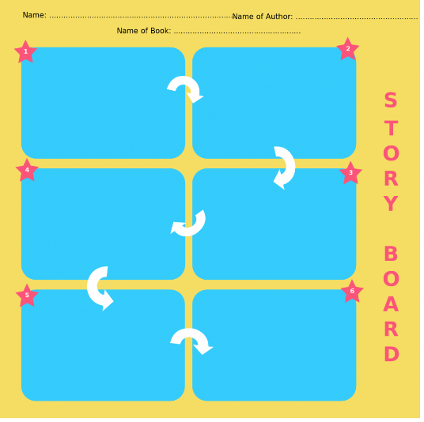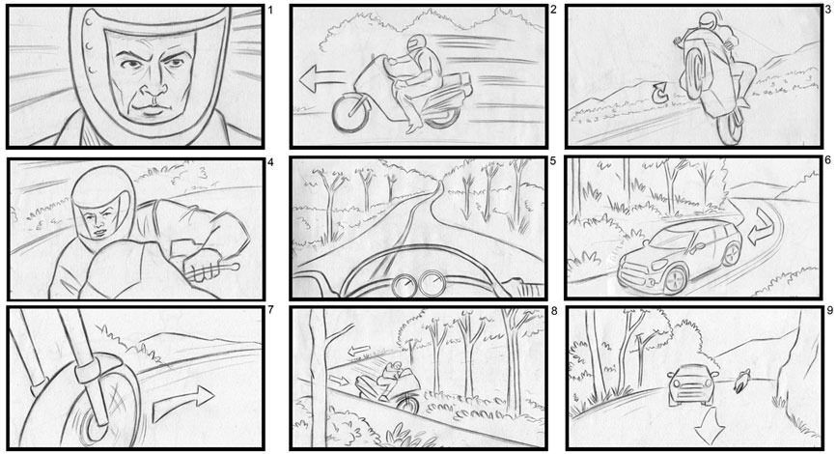





+CHILDNAME+ jumped into their storytelling with a very vital part of the process today!

After having an amazingly creative time with adventure maps, playing with filming/editing software and creating +hisher+ own set. We now have to pivot and begin thinking about the planning that occurs behind great imaginative projects.

When writers in various fields want to make ideas easily understood, they choose a storyboard format! Just like most children +CHILDNAME+ seemed to love this session with a larger graphic focus and when +heshe+ got to organise all those awesome ideas into one great story, they loved it even more! +CHILDNAME+ was naturally attracted to drawing things up in this storyboarding stage with our hands on drawing as after all, it takes some practise to compile their creativity into one flow.

Another important lesson that we learnt here is that this also helped +CHILDNAME+ organize their ideas and present them in an orderly manner. We added some colourful and eye-catching examples to help along the way to bringing this epic tale to life!





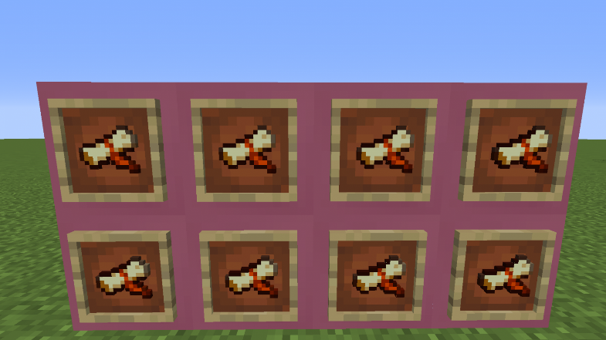

Today +CHILDNAME+ used their creative writing skills to journey down the next development stage for +hisher+ epic movie!

If you like to read and you like to watch movies, you’ve probably thought that you could write a movie yourself. Have you? Be honest!

In this session +CHILDNAME+ weaved together an interesting story +heshe+ wanted to tell within their newly created film set. We covered the basics of script/concept writing in a nutshell to help kickstart the storytelling process. There is much more to learn as we progress and experiment, but this initial mind map got  +CHILDNAME+ pointed in the right direction.

Telling a fun and engaging story is no easy task! It takes some trial and error to get things right which is why planning is crucial. +HESHE+ can get as creative is possible in this exercise, something that we love to actively encourage. We also implemented a sprinkle of social work and collaboration as +CHILDNAME+  invited other ninjas to provide some additional acting talent, by way of character voicing or custom sound effects!

In the end we had a script worthy of an academy award (after a few more tweaks) Next it was time to put all this preparation into action! Well done so far +CHILDNAME+!